|  |
| --- |
| , RD Dep. |
| **Introduction to OLAP** |

|  |  |  |  |  |  |
| --- | --- | --- | --- | --- | --- |
| REVISION HISTORY | | | | | |
| Ver. | Description of Change | Author | Date | Approved | |
| Name | Effective Date |
| 1.0 | Initial Version | Mikita Kandratsiuk | 14-Nov-2017 |  |  |
| 2.0 | Report overview | Hanna Klimovich | 15-NOV-2017 |  |  |

Contents

1. Frameworks 3

2. Presentation 3

3. SQL for analysis 3

# 

# Presentation

Presentations about methodologies.

|  |  |  |
| --- | --- | --- |
| Aksana Kuratnik |  | Kanban |
| Aliaksandr Labayeu |  |  |
| Vitaliya Adamchuk |  |  |
|  |  |  |
| Saida Melikava |  | Scrum |
| Valeryia Lupanava |  |  |
|  |  |  |
| Alina Makarets |  | Agile |
| Arina Marchenko |  |  |
| Hanna Takushevich |  |  |
|  |  |  |
| Mikita Tur |  | Other |
| Olga Hilko |  |  |
|  |  |  |
| Gleb Kulvanovski |  | Waterfall |
| Anastasiya Khilko |  |  |
| Hanna Hul |  |  |

# SQL for analysis

1. Topic 2. Task 2 (please, make an example of usage GROUPING_ID).

Analyze max, min and summary sales in the report below by:

✓ December 2000;

✓ Two channels: Internet and Direct Sales;

✓ All States.

Build the query using Oracle SQL for Aggregation and design the same report (export results to Excel).

SELECT DECODE(GROUPING(calendar_month_desc),1, 'GRAND TOTAL', calendar_month_desc) AS YEAR_MONTH,

CASE

WHEN GROUPING_id(calendar_month_desc, channel_desc)=1

THEN 'Total by Channels'

WHEN sh.channels.channel_desc IS NULL

THEN' '

ELSE sh.channels.channel_desc

END AS Channel,

CASE

WHEN grouping_id(sh.channels.channel_desc,sh.countries.country_name)=1

THEN sh.channels.channel_desc

|| ' Total By States'

WHEN sh.countries.country_name IS NULL

THEN' '

ELSE sh.countries.country_name

END AS Country,

ROUND(MAX(amount_sold)) AS MAX_SALES$,

ROUND(MIN(amount_sold)) AS MIN_SALES$,

ROUND(SUM(amount_sold)) AS SALES$

FROM sh.sales

LEFT JOIN sh.channels

ON sh.sales.channel_id=sh.channels.channel_id

LEFT JOIN sh.times

ON sh.sales.time_id=sh.times.time_id

LEFT JOIN sh.customers

ON sh.sales.cust_id=sh.customers.cust_id

LEFT JOIN sh.countries

ON sh.customers.country_id=sh.countries.country_id

WHERE calendar_month_desc ='2000-12'

AND (channel_desc = 'Internet'

OR channel_desc = 'Direct Sales')

GROUP BY ROLLUP(calendar_month_desc, channel_desc, country_name);

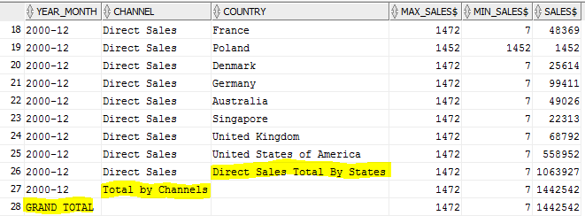

CASE

WHEN grouping_id(sh.channels.channel_desc,sh.countries.country_name)=1

THEN sh.channels.channel_desc

|| ' Total By States'

WHEN sh.countries.country_name IS NULL

THEN' '

ELSE sh.countries.country_name

END

1. Concatenation allows dynamically insert required cannel_desc.
2. Grouping_is is used: a is our situation, when country_name is null because of rollup grouping_id is 1.

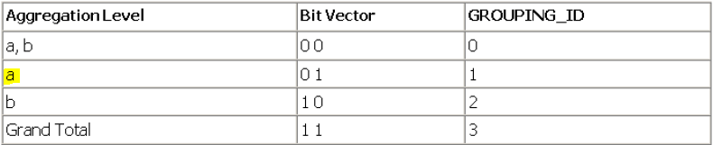

1. Here also NULL replacement is implemented, but it’s **not necessary** , because when we export in Excel it will be shown as blank space.
2. Groupings and grouping_id’s of different levels were used.
3. GROUP BY ROLLAP was used.
4. Topic 3. Task 2.

Напишите запрос для формирования отчёта о продажах в Азии всех продуктов из категории Photo за 2000 год по кварталам. Вычислите итоговые суммы (TOTAL и YEAR_SUM).

WITH quarter AS

( SELECT DISTINCT sh.products.prod_name AS prod_name,

NTH_VALUE(SUM(AMOUNT_SOLD),1) OVER (PARTITION BY prod_name ORDER BY sh.times .calendar_quarter_number ASC RANGE BETWEEN UNBOUNDED PRECEDING AND UNBOUNDED FOLLOWING) AS Q1,

NTH_VALUE(SUM(AMOUNT_SOLD),2) OVER (PARTITION BY prod_name ORDER BY sh.times .calendar_quarter_number ASC RANGE BETWEEN UNBOUNDED PRECEDING AND UNBOUNDED FOLLOWING) AS Q2,

NTH_VALUE(SUM(AMOUNT_SOLD),3) OVER (PARTITION BY prod_name ORDER BY sh.times .calendar_quarter_number ASC RANGE BETWEEN UNBOUNDED PRECEDING AND UNBOUNDED FOLLOWING) AS Q3,

NTH_VALUE(SUM(AMOUNT_SOLD),4) OVER (PARTITION BY prod_name ORDER BY sh.times .calendar_quarter_number ASC RANGE BETWEEN UNBOUNDED PRECEDING AND UNBOUNDED FOLLOWING) AS Q4,

SUM(SUM(AMOUNT_SOLD)) OVER (PARTITION BY prod_name) AS YEAR_SUM

FROM sh.sales

LEFT JOIN sh.products

ON sh.sales.prod_id=sh.products.prod_id

LEFT JOIN sh.times

ON sh.sales.time_id=sh.times.time_id

LEFT JOIN sh.channels

ON sh.sales.channel_id=sh.channels.channel_id

LEFT JOIN sh.customers

ON sh.sales.cust_id=sh.customers.cust_id

LEFT JOIN sh.countries

ON sh.customers.country_id =sh.countries.country_id

WHERE sh.times.calendar_year ='2000'

AND country_region ='Asia'

AND prod_category ='Photo'

GROUP BY sh.products.prod_name,

sh.times .calendar_quarter_number

)

SELECT NVL(sh.products.prod_name,'TOTAL') AS Prod_name,

SUM(Q1) AS Q1,

SUM(Q2) AS Q2,

SUM(Q3) AS Q3,

SUM(Q4) AS Q4,

SUM(year_sum)

FROM quarter q

LEFT JOIN sh.products

ON q.prod_name=sh.products.prod_name

GROUP BY rollup(sh.products.prod_name) ;

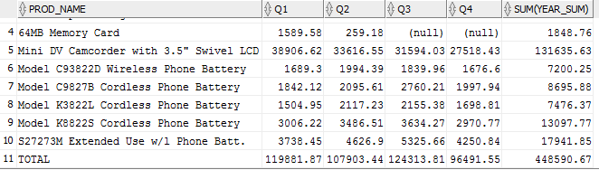

1. NTH_VALUE function was used:

NTH_VALUE (SUM(AMOUNT_SOLD),4) OVER (PARTITION BY prod_name

ORDER BY sh.times .calendar_quarter_number ASC

RANGE BETWEEN UNBOUNDED PRECEDING AND UNBOUNDED FOLLOWING)

NTH_VALUE lets you find a **specific position in the analytic window** such as 2nd, 3rd, or 4th value

We partition our table by prod_name’s and then ordered them by quarters:

|  |  |  |
| --- | --- | --- |
| Prod 1 | Q1 | 1st value |
| Q1 | 1st value |
| Q1 | 1st value |
| Q2 | 2nd value |
| Q2 | 2nd value |
| Prod 2 | Q1 | 1st value |
| Q2 | 2nd value |
| … |  |  |

RANGE BETWEEN UNBOUNDED PRECEDING AND UNBOUNDED FOLLOWING – All rows are included in the window, regardless of the current row.

1. Your personal example of PIVOT

CREATE TABLE SALES_VIEW AS

SELECT PROD_NAME PRODUCT,

COUNTRY_NAME COUNTRY,

CHANNEL_ID CHANNEL,

SUBSTR(CALENDAR_QUARTER_DESC, 6,2) QUARTER,

SUM(AMOUNT_SOLD) AMOUNT_SOLD,

SUM(QUANTITY_SOLD) QUANTITY_SOLD

FROM sh.SALES,

sh.TIMES,

sh.CUSTOMERS,

sh.COUNTRIES,

sh.PRODUCTS

WHERE sh.SALES.TIME_ID = sh.TIMES.TIME_ID

AND sh.SALES.PROD_ID = sh.PRODUCTS.PROD_ID

AND sh.SALES.CUST_ID = sh.CUSTOMERS.CUST_ID

AND sh.CUSTOMERS.COUNTRY_ID = sh.COUNTRIES.COUNTRY_ID

GROUP BY PROD_NAME,

COUNTRY_NAME,

CHANNEL_ID,

SUBSTR(CALENDAR_QUARTER_DESC, 6, 2) ;

SELECT *

FROM

(SELECT PRODUCT, CHANNEL, AMOUNT_SOLD FROM SALES_VIEW

) PIVOT (SUM(AMOUNT_SOLD) FOR CHANNEL IN (2 AS PARTNERS, 3 AS DIRECT_SALES, 4 AS INTERNET_SALES, 9 AS TELESALES))

ORDER BY PRODUCT;